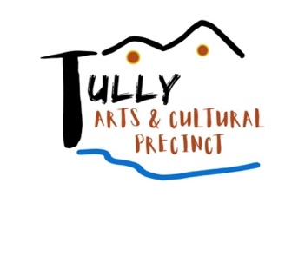
TRADITION, RITUAL, COMMUNITY - EXHIBITION
(July 10 to 26, 2026)
APPLICATION FORM
Please complete and forward to: Tully Arts and Cultural Precinct Inc.,
PO Box 795, Tully Qld 4854, 0484 282 888 or email tullyprecinct@gmail.com
ENTRY FORMS & PAYMENT MUST BE RECEIVED BY Monday June 2, 2026
Artwork should reference the theme Traditional, Ritual, Community. Inspired by 100 years of community service by the Tully Masons this exhibition will provide opportunities for local artists to look to their own lives to interrogate the themes of tradition, ritual and community and convey what it means to them through visual narrative.
ARTIST
Name:
Address:
Phone Number:
Email Address:

Are you registered for GST? YES / NO ABN: _________________________________________

Artwork Title:
Medium:
Size: | H: | W: | D:
Artwork Completion Date |  | Month | Year: 202
Should your artwork exceed 100cm x 100cm (including frame) contact exhibition organisers to discuss.
Price: | Your price should allow a 20 % commission which would be applicable on all sales |  | $
Method of display: | Wall hung, plinth, ceiling or floor display
Entry Fee: |  |  | $15.00
Bank details: | BSB: 633 000 Account no: 221 298 532
 | Please include your surname as reference when depositing entry fee.

- All artwork must be clearly labelled on the back with Artist Name, Title and Size
- All artwork must be gallery ready with appropriate hanging or display attachments
- Artwork completion date not before January 1, 2025.
- Not all artwork may be relevant or suitable for exhibition and the coordinators of The Tully Arts and Cultural Precinct exhibition have the final say on the selection process.

COPYRIGHT: By signing this form, you acknowledge that the work is your own and give the Tully Arts and Cultural Precinct permission to reproduce artworks in an exhibition catalogue (if selected) and for non-commercial purposes to promote the exhibition.

Date______________________________ Signature: ______________________________

Gallery didactics and a catalogue (selected artists/artworks) will be prepared for the Tradition, Ritual, Community exhibition. Please provide the following information for display and catalogue Purposes:

A short bio of your arts practice (100 words):

The story of your artwork (200 words) - what does the theme Tradition, Ritual, Community mean to you.

KEY DATES:
Monday June 2 | Entry form and payment received
Friday June 12 | If requested a clear digital image of your artwork for catalogue
Sunday or Monday July 5 or 6 (0900 – 2pm) | Artwork to be delivered to Tully Masonic Centre
Friday July 10 6pm | Exhibition Launch at Tully Masonic Centre
Monday/Tuesday July 27 & 28 | Artwork to be collected at the Tully Masonic Centre

There is potential for us to tour the Tradition, Ritual, Community exhibition after its May Launch and request that you confirm your interest in having your work included in this touring exhibition. If artwork is sold further permission from purchaser will be required. Yes/No

I agree to Tully Arts and Cultural Precinct exhibition information and accept the terms and conditions provided in this document.

Date: ___________________________ Signature: _____________________________________

